

**Assignment**

**Of**

**Android Mobile Application Development**

**Submitted To:**

**Sir.Zeeshan Bhatti**

**Professor Dept:**

**Information Technology**

**Submitted By:**

**Mubashir Ali S/O**

**Mansoor Ali**

**(2k20/ITE/73)Group(A)**

**LAB Projects for Week-1**

**Lab Task 1 to 3 - Last Date Wed-26 Oct**

***TASK 1:***

**Download and Install Android Studio.**

Every student must download and install Android Studio in this personal systems.

***Output:***

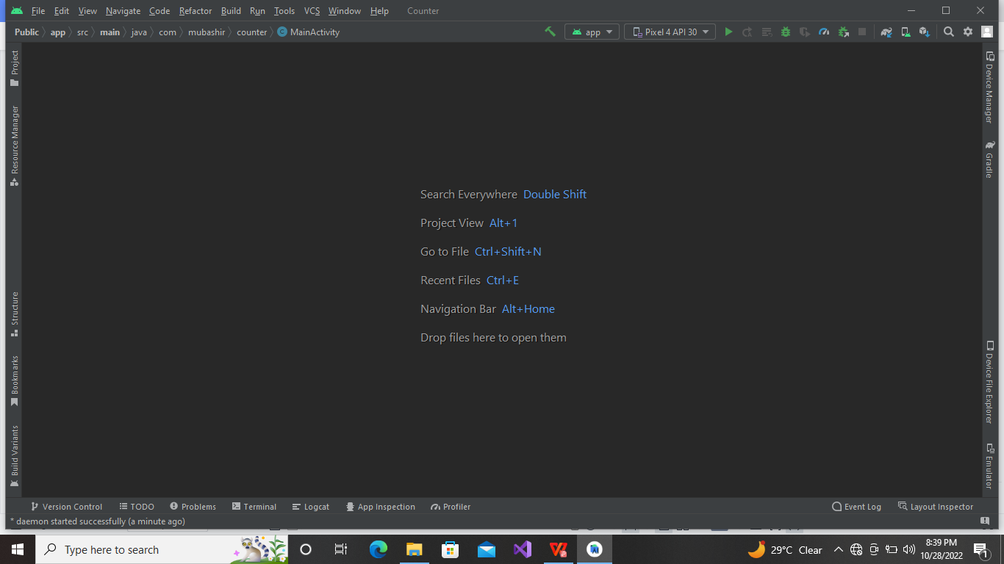

***TASK 2:***

**Create a simple Counter App in Android Studio.**

The requirements of this app are that there needs to be a Count Button, which increments a number and display

it on screen ever time the button is clicked as shown in figure below.

***Source Code:***

package com.mubashir.counter;  
  
import androidx.appcompat.app.AppCompatActivity;  
  
import android.os.Bundle;  
import android.view.View;  
import android.widget.Button;  
import android.widget.TextView;  
  
public class MainActivity extends AppCompatActivity {  
 int Counter;  
  
 @Override  
 protected void onCreate(Bundle savedInstanceState) {  
 super.onCreate(savedInstanceState);  
 setContentView(R.layout.*activity_main*);  
  
 TextView txtCount = findViewById(R.id.*txtCounter*);  
 Button btnCount = findViewById(R.id.*btnCounter*);  
 Button btnReset = findViewById(R.id.*btnReset*);  
  
 Counter=0;  
 btnCount.setOnClickListener(new View.OnClickListener(){  
 @Override  
 public void onClick(View view) {  
 Counter++;  
 txtCount.setText(""+Counter);  
 }  
 });  
  
 btnReset.setOnClickListener(new View.OnClickListener(){  
 @Override  
 public void onClick(View view) {  
 Counter=0;  
 txtCount.setText(""+Counter);  
 }  
 });  
  
 }  
}

***Output:***

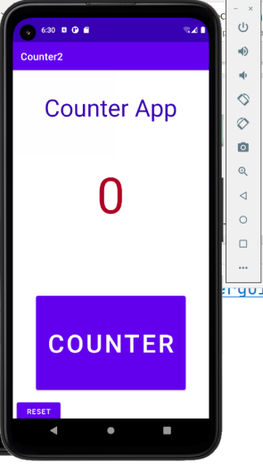

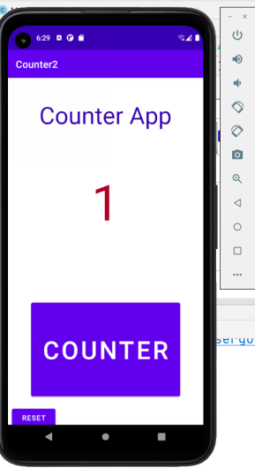

***TASK 3:***

**Create a Tasbeeh App in Android Studio.**

The requirements of this app are that there needs to be a 5 buttons, button one should count the Tasbeeh, then

each separate button for limiting the count to 33 times, 100 times, No limit and reset button, which increments a

number and display it on screen ever time the button is clicked as shown in figure below.

***Source Code:***

package com.mubashir.counter;  
 import androidx.appcompat.app.AppCompatActivity;  
 import android.os.Bundle;  
 import android.view.View;  
 import android.widget.Button;  
 import android.widget.TextView;  
public class MainActivity extends AppCompatActivity {  
 int counter;  
 int limit;  
 @Override  
 protected void onCreate(Bundle savedInstanceState) {  
 super.onCreate(savedInstanceState);  
 setContentView(R.layout.*activity_main*);  
 TextView txtCount = findViewById(R.id.*txtCounter*);  
 TextView btnCount = findViewById(R.id.btnTasbeeh);  
 Button btn33 = findViewById(R.id.btn33);  
 Button btn100 = findViewById(R.id.btn100);  
 Button btnReset = findViewById(R.id.*btnReset*);  
 Button btnnoLimit = findViewById(R.id.btnNolimit);  
 counter=0;  
 limit=0;  
 btnCount.setOnClickListener(new View.OnClickListener() {  
 @Override  
 public void onClick(View v) {  
 //counter++;  
 if(limit==33 && counter<33){  
 counter++;  
 }  
 else if(limit==100 && counter<100){  
 counter++;  
 }  
 else if(limit==0){  
 counter++;  
 }  
 txtCount.setText(""+counter);  
 }  
 });  
 btnReset.setOnClickListener(new View.OnClickListener() {  
 @Override  
 public void onClick(View v) {  
 counter=0;  
 txtCount.setText(""+counter);  
 }  
 });  
 btn33.setOnClickListener(new View.OnClickListener() {  
 @Override  
 public void onClick(View v) {  
 limit=33;  
 }  
 });  
 btn100.setOnClickListener(new View.OnClickListener() {  
 @Override  
 public void onClick(View v) {  
 limit=100;  
 }  
 });  
 btnnoLimit.setOnClickListener(new View.OnClickListener() {  
 @Override  
 public void onClick(View v) {  
 limit=0;  
   
 }  
 });  
 } }

***Output:***

